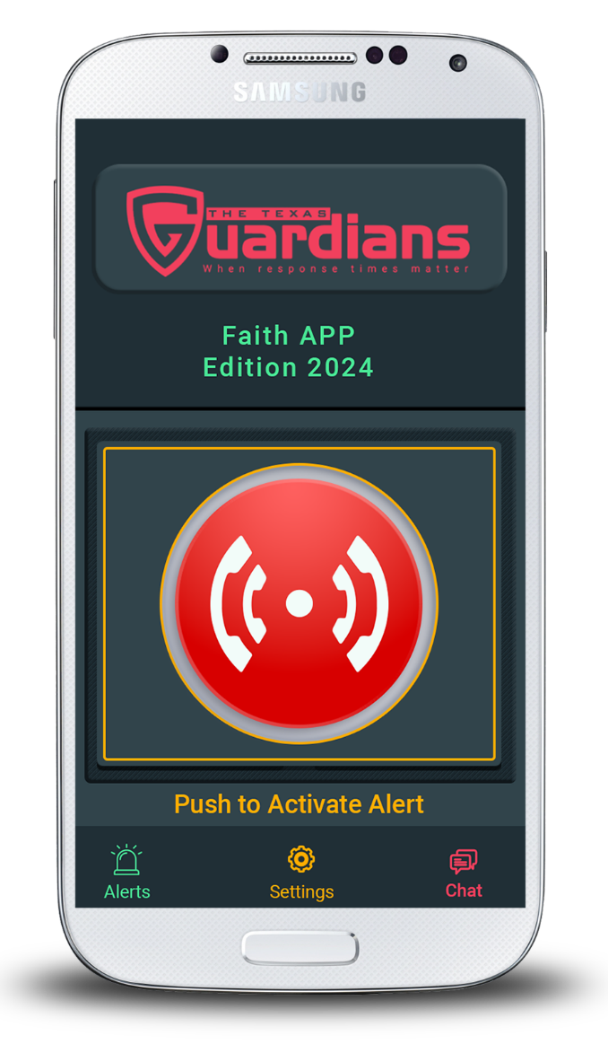

About Us

260 S, Texas Blvd Suite 402 Weslaco Texas, 78596  
Monday to Friday, 9am to 6pm

FAITH

If you’re on the hunt for professional App Developers with loads of experience, you’ve come to the right place. We’ve been providing exceptional Apps to clients across the country and around the world. We help to solve issues standing between the idea and the materialization of a product. With over thousands of different mobile phones in the market, Lightning Cellphones and Accessories is dedicated to always source for and provide the public with top tier mobile specifications and services available in the mobile phone market.

Get in Touch

By The Texas Guardians

Mission - Vision

App  
is Attached  
with the  
Powerful  
Admin Panel

Our mobile safety solutions is for all segments of the population that includes individuals, Medical organizations, School Districts, Universities, Congregations, Businesses, Bail Bondsmen, and Law Enforcement. Our Smart phone technology is specifically designed to summon help from any type of emergencies and instantly interfaces with first res-ponders to provide a faster response time. ​ It also provides a greater level of personal safety and can measure risks before it happens.

ON  
Google  
Play Store

Available

Contact us

+ 956-463-0521www.thetexasguardians.com  
roy@thetexasguardians.com

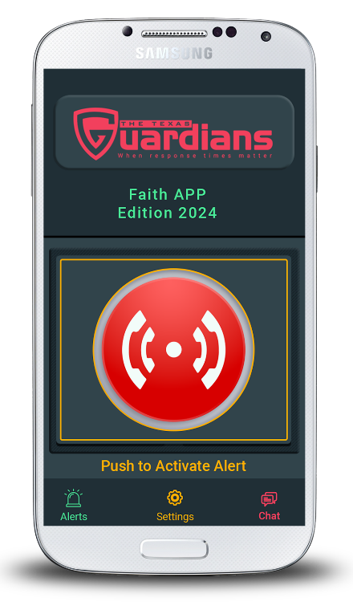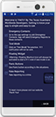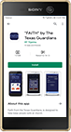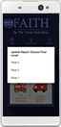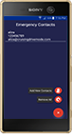

"Faith" by The Texas Guardians offers congregations a place of comfort, hope, and peace during worshiping. This App is for congregations that is wanting to add an extra layer of security/protection during an active shooter or any other threat that is encountered. Law enforcement and other first responders will instantly get a notification with the exact coordinates along with the name of the congregation, a brief message explaining the situation, and in most cases what the active shooter looks like with a click of a button. Our App can also report suspicious behaviors, if a gun or knife is spotted, someone is poisoned, killed, someone wants to commit suicide, bullying, when talk of a bomb is overheard, and customs reports can be created.

Best Safety  
App

* Primary Panic Buttons
* Emergency Contacts
* Instant Report
* Share Current Location with Report
* Create Custom Report
* Shortcut Reporting Button
* Test Mode
* Friendly User interface
* Easy to operate
* No Training Required
* 24/7 Support

Top Features

Emergency Contacts

App for iOS and Android

App Features

Choose the Floor after submit any emergency report.

Add trusted emergency contacts in the App, App will send the Emergency Reports to them instantly.

From the App setting, add the profile information, Emergency contacts or turn on Test Mode.

App is available on the Play store, just go to play store and search Faith by The Texas Guardians.

Setting

Download App

Choose Floor